TECHNICAL SERGEANT TYLER S. BOUDREAU
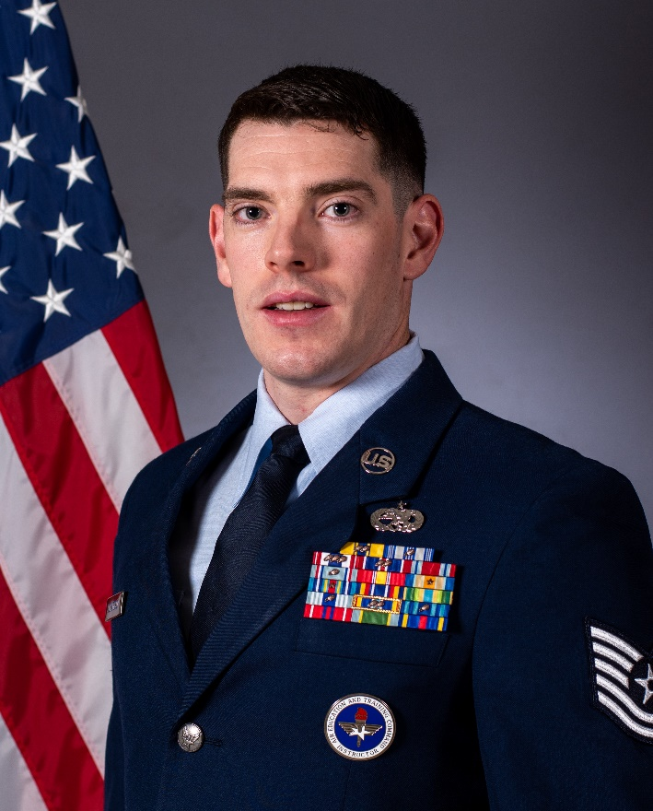
Technical Sergeant Tyler Boudreau is the first enlisted Air Force Reserve Officer Training Corps (AFROTC) Training Instructor at Arizona State University Detachment 025, Arizona State University, Tempe, Arizona. Sergeant Boudreau serves as the detachment’s Key Enlisted Leader and as the primary enlisted advisor to the detachment commander on cadet academics, professional development programs, military training and discipline. He also supports cadet life cycle management and completes actions for contracting, commissioning, extended active duty and AFROTC Field Training.

Sergeant Boudreau entered the Air Force in March 2014 later completing Basic Military Training at Lackland Air Force Base. He attended Technical Training at Sheppard Air Force Base learning the basic skills of a C-130H Crew Chief. October 2014 He was assigned to the 374th Airlift Wing, Yokota Air Base, Japan as an Isochronal Crew Chief. Preforming major inspections, repairs and modifications to a fleet of 14 C-130Hs valued at $2 billion. While supporting humanitarian missions throughout the United States Indo-Pacific Command air lifting 260,000 pounds of cargo. Then in October 2016 he was assigned to the 27th Special Operations Wing, Cannon Air Force Base, New Mexico. Where he served as an AC-130W dedicated Crew Chief. Leading the Air Force Special Operations Command’s largest Squadron. During his stay at Cannon Air Force Base, Sergeant Boudreau’s team answered their first Presidential Directed Mission, to defend the American Embassy in Iraq. He answered the second mission to defend NATO forces, where 34 insurgents’ advancement were halted on an American forward operating base.

Sergeant Boudreau deployed three times with the Joint Special Operations Air Command in support of Operation INHERENT RESOLVE. Over his deployments he provided overwatch to 12,200 United States and Coalition Ground Forces, enabled 439 combat missions, expended 53,000 rounds and 416 small diameter bombs on target, destroying 1,200 vehicle borne improvised explosive devices, capturing 18 high value targets of the Islamic State and eliminating 429 enemies of the United States of America. His efforts resulted in the liberation of Syria and Iraq from Islamic State control and the freeing of one million civilians.

EDUCATION
2014 Basic Military Training, Lackland AFB, TX
2018 Airman Leadership School, Cannon Air Force Base, NM
2020 Senior Enlisted Joint Professional Military Education, Cannon AFB, NM
2021 Associate in Aviation Maintenance Technology, Community College of the Air Force, AL
2022 Detachment Cadre Instructor Course, Maxwell AFB, AL
.
ASSIGNMENTS or CAREER CHRONOLOGY
- October 2014 – October 2016, Isochronal Crew Chief, 374 Aircraft Maintenance Squadron, Yokota Air Base, Japan
- October 2016 – August 2022, AC-130 Noncommissioned Officer in Charge, 27 Special Operations Aircraft Maintenance Squadron, Cannon Air Force Base, NM
(May 2017 – October 2017, AC-130W Crew Chief, 16th Expeditionary Special Operations Squadron, Al Assad AB, Iraq)
(November 2018 – March 2019, AC-130W Crew Chief, 16th Expeditionary Special Operations Squadron, Al Assad AB, Iraq)
(March 2020 – July 2020, AC-130W Crew Chief, 16th Expeditionary Special Operations Squadron, Al Assad AB, Iraq)

MAJOR AWARDS AND DECORATIONS
Air Force Commendation Medal 3rd oak leaf cluster
Air Force Achievement Medal 1st oak leaf cluster

OTHER ACHIEVEMENTS
2015 374th Maintenance Group Commander Coin
2017 Operation Inherent Resolve Commander Coin
2018 27th Special Operations Maintenance Group Dedicated Crew Chief of the Quarter
2018 Joint Special Operations Air Component Commander Coin
2018 101st Army Battalion Commander Coin
2019 27th Special Operations Maintenance Group Commander Coin
2019 20th Special Operations Squadron Commander Coin
2020 386th Air Expeditionary Wing Command Chief Coin

EFFECTIVE DATES OF PROMOTION

Airman Basic March, 2014
Airman September 2014
Airman First Class June 2015
Senior Airman June 2016
Staff Sergeant May 2018
Technical Sergeant May 2020

(Current as of NOVEMBER 2022)

