SCHOOL |  | DATE
 | Air Force ROTC Detachment XXX  Practical Military Training Operations Order ( PMT OPORD) | Det logo here
1. Situation:  PMT Explanation | All activities listed are considered PMT events. IAW AFROTCI 36‐2011, para 10.3. PMT for AFROTC includes LLAB, PT, FT and Professional Development Training (PDT). PMT is AFROTC-sponsored training that is uniquely military and meets the requirements in Title 10 U.S.C. 2109.  mPMT: any AFROTC sponsored training activity designed to present training objectives; vPMT: any sponsored military related training activity that the Det CC designates as voluntary PMT.
Guidance | All cadets have access to the following instructions:  - AFROTCI 36-2011, Cadet Operations - T-509, Cadet’s Guide to LLAB Curriculum

1. Mission | Week XX/ Type of PMT (LLAB/ PT/ Other specified)
a. Background | Voluntary of Mandatory PMT |  |  |  |  |  |  |  |  | b. Date/Time
c. UOD |  |  |  |  |  |  |  |  |  | d. Main Location |  |  |  | Primary location for PMT event
2. Execution | a. Cadets | b. Activity |  |  |  |  |  |  |  | c. Location |  |  |  | d. Time |  |  |  | e. OPR
 | IMT/SCL | Drill Movements |  |  |  |  |  |  |  | WFH |  |  |  | 0530-0600 |  |  |  | OSS/CC
 | FTP/ICL | Commanding a Flight |  |  |  |  |  |  |  | WFH |  |  |  | 0530-0600 |  |  |  | OSS/CC
 | ALL | Honor Code Lesson |  |  |  |  |  |  |  | WFH |  |  |  | 0600-0610 |  |  |  | OSS/CC
 | ALL | Customs & Courtesies |  |  |  |  |  |  |  | WFH |  |  |  | 0610-0620 |  |  |  | OSS/CC
 | ALL | Grooming/Uniform Standards |  |  |  |  |  |  |  | WFH |  |  |  | 0620-0630 |  |  |  | OSS/CC
 | ALL | Flag Customs & Courtesies |  |  |  |  |  |  |  | WFH |  |  |  | 0630-0640 |  |  |  | OSS/CC
3. Admin | a. Objectives
 | List all objectives to be accomplished for this specific PMT event
 | b. Weather
 | Event will be conducted: |  |  | Indoors/Outdoors
 | Projected Weather Forecast:  (Source: http://www.accuweather.com) |  |  | Sunny |  |  | High: | 82° |  |  | Low: | 62° | Precip: |  | 25% |  | Winds / Gusts: |  | 5 / 8 mph | CAO Date:
 | Impact Plan: |  |  | In case of weather-related impacts/cancellations, determined by Cadre or campus admin, the CW/CC will ensure all cadets are notified ASAP as to the mitigation plan / cancellation of PMT.
c. Risk Management | IAW AFROTCI36-2011, para 1.13.7 Risk management has been incorporated into all facets of the detachment, to include the training program. This 5-step Deliberate process is IAW AFI90-802 Risk Management. Any activity determined to be of medium or high risk after control measures are implemented must receive Det Commander approval.
 | Step 1:  ID Hazards |  | Step 2:  Assess Risk |  |  |  |  |  | Step 3:  Controls Measure |  |  |  |  |  |  | Step 4:  Implementation |  |  |  | Step 5:  Supervise
 | Hazard / Causes |  | Severe |  | Prob | Assessment |  |  | Mitigation Measure |  |  |  | New Assessment |  |  | Method |  |  |  | CW/CC Initials | OFC Initials
 | Inclement Weather |  | IV |  | F | Low |  |  | LLab is indoors |  |  |  | Low |  |  | See Wx impact plan, notify cadets of Wx hazards for transit
 | Overall  Risk Assessment |  |  |  |  |  |  |  | Overall Risk after Controls |  |  |  |  |  |  | Det/CC Approval if more than Medium |  |  |  | Det/CC Initials
SCHOOL |  | DATE
 | Air Force ROTC Detachment XXX  Practical Military Training Operations Order (OPORD) cont. | Det logo here

1. Mission | Week XX/ Type of PMT (LLAB/ PT/ Other specified)
a. Background | Voluntary of Mandatory PMT |  |  |  |  |  |  |  |  | b. Date/Time
c. UOD |  |  |  |  |  |  |  |  |  | d. Main Location |  |  |  | Primary location for PMT event
2. Execution | a. Cadets | b. Activity |  |  |  |  |  |  |  | c. Location |  |  |  | d. Time |  |  |  | e. OPR
 | IMT/SCL | Drill Movements |  |  |  |  |  |  |  | WFH |  |  |  | 0530-0600 |  |  |  | OSS/CC
 | FTP/ICL | Commanding a Flight |  |  |  |  |  |  |  | WFH |  |  |  | 0530-0600 |  |  |  | OSS/CC
 | ALL | Honor Code Lesson |  |  |  |  |  |  |  | WFH |  |  |  | 0600-0610 |  |  |  | OSS/CC
 | ALL | Customs & Courtesies |  |  |  |  |  |  |  | WFH |  |  |  | 0610-0620 |  |  |  | OSS/CC
 | ALL | Grooming/Uniform Standards |  |  |  |  |  |  |  | WFH |  |  |  | 0620-0630 |  |  |  | OSS/CC
 | ALL | Flag Customs & Courtesies |  |  |  |  |  |  |  | WFH |  |  |  | 0630-0640 |  |  |  | OSS/CC
3. Admin | a. Objectives
 | List all objectives to be accomplished for this specific PMT event
 | b. Weather
 | Event will be conducted: |  |  | Indoors/Outdoors
 | Projected Weather Forecast:  (Source: http://www.accuweather.com) |  |  | Sunny |  |  | High: | 82° |  |  | Low: | 62° | Precip: |  | 25% |  | Winds / Gusts: |  | 5 / 8 mph | CAO Date:
 | Impact Plan: |  |  | In case of weather-related impacts/cancellations, determined by Cadre or campus admin, the CW/CC will ensure all cadets are notified ASAP as to the mitigation plan / cancellation of PMT.
c. Risk Management | IAW AFROTCI36-2011, para 1.13.7 Risk management has been incorporated into all facets of the detachment, to include the training program. This 5-step Deliberate process is IAW AFI90-802 Risk Management. Any activity determined to be of medium or high risk after control measures are implemented must receive Det Commander approval.
 | Step 1:  ID Hazards |  | Step 2:  Assess Risk |  |  |  |  |  | Step 3:  Controls Measure |  |  |  |  |  |  | Step 4:  Implementation |  |  |  | Step 5:  Supervise
 | Hazard / Causes |  | Severe |  | Prob | Assessment |  |  | Mitigation Measure |  |  |  | New Assessment |  |  | Method |  |  |  | CW/CC Initials | OFC Initials
 | Inclement Weather |  | IV |  | F | Low |  |  | LLab is indoors |  |  |  | Low |  |  | See Wx impact plan, notify cadets of Wx hazards for transit
 | Overall  Risk Assessment |  |  |  |  |  |  |  | Overall Risk after Controls |  |  |  |  |  |  | Det/CC Approval if more than Medium |  |  |  | Det/CC Initials

4. Approval
a. CW/CC Approval/Signature
b. OFC  Approval /Signature |  | APPROVE |  | DISAPPROVE | DATE

6. PMT Time Deviation Waiver Approval (if applicable)
a. Guidance | IAW AFROTCI 36-2011, paragraph 10.3.4.4, Limit all PMT to no more than 6 hours per week (Monday through Sunday). The Det/CC holds approval authority to exceed weekly limit.
b. Deviation | Cadets Affected |  |  |  |  | Deviation Amt |  | Total PMT
c. Justification
d. Det/CC  Approval /Signature |  | APPROVE |  |  | DISAPPROVE |  |  |  | DATE:
FIRST M. LAST, Lt Col, USAF
Commander, AFROTC Detachment XXX
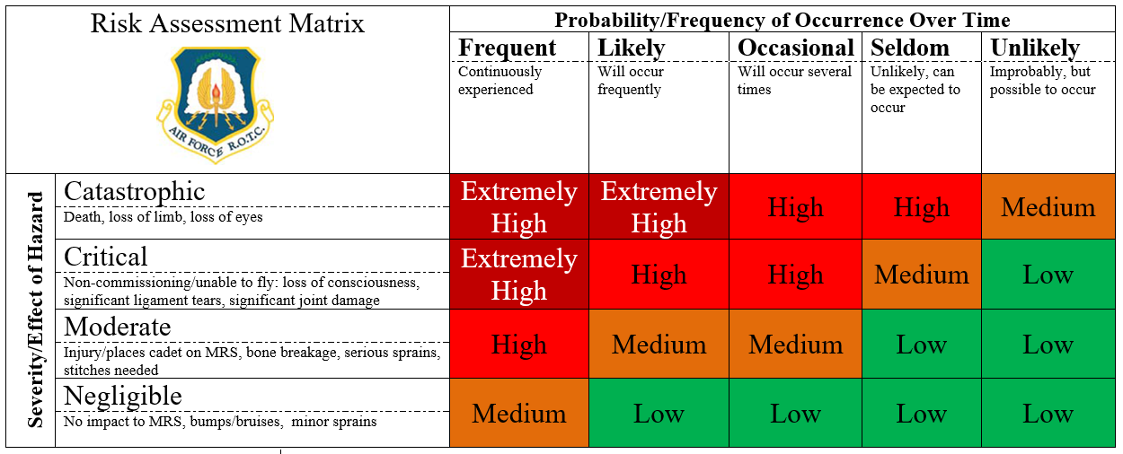
(S)
(O)
(L)
(F)
(U)
(IV)
(III)
(II)
(I)

